

Qlik Cloud Monitoring Applications Installation Guide

Step-by-step instructions to install and configure the Qlik Cloud Monitoring applications.

TABLE OF CONTENTS

Prerequisites 3

Pre-configuration Check 3

Another Monitoring Application Has Already Been Configured 3

Configure the Tenant for Monitoring Applications 4

Setup User for Development Access 4

Configure API Settings and Generate API Key 5

Create Data Connection for the Monitoring Apps 8

Import and Configure the Monitoring Application 11

Import the Monitoring Application 11

Configure the Monitoring Application 12

Troubleshooting 14

Reload Analyzer 14

App Analyzer 15

|  |
| --- |
| The Qlik Cloud Monitoring Apps Install Guide and applications are provided as-is. They are not covered under the [Qlik Support Policy](https://www.qlik.com/us/legal/product-terms). No information from the apps is provided to Qlik. It is recommended to always use the latest version of the apps. |

INTRODUCTION

|  |
| --- |
|  |
| Connect with us!    Subscribe to the Qlik Support Updates Blog   * Get up to date information on new releases. * Stay informed about current product insights and new features.   >> [click here](https://community.qlik.com/t5/Qlik-Support-Updates-Blog/bg-p/qlik-support-updates-blog) <<    Join Qlik Community   * Connect with an ever-growing audience of active Qlik enthusiasts. * Share Tips & Tricks and best practices.   >> [click here](https://community.qlik.com/t5/Qlik-Support-Updates-Blog/bg-p/qlik-support-updates-blog) <<    Expand your Knowledge   * Access an evolving database of   Qlik Product knowledge   * Get in touch with our world-class Support.   >> [click here](https://support.qlik.com/) << |

This guide breaks down the configuration installing a Qlik Cloud monitoring application step-by-step. All Qlik Cloud monitoring applications follow the same setup process and leverage the same data connection. Once this process has been completed for a single monitoring application, it can be reused across all others. The last section of the guide which covers any modifications that might need to be done at the script level might vary by application and is documented as such.

The current Qlik Cloud monitoring applications can be found [here](https://community.qlik.com/t5/Official-Support-Articles/The-Qlik-Sense-Monitoring-Applications-for-Cloud-and-On-Premise/ta-p/1822454).

|  |
| --- |
| Note that there is a separate installation guide for the **OEM Dashboard** monitoring application. The installation and configuration of that application is not covered within this guide. |

# Prerequisites

* Familiarity with the Data Load Editor is recommended
* User with **TenantAdmin** access

# Pre-configuration Check

## Another Monitoring Application Has Already Been Configured

If another monitoring application has already been configured, this means that the prerequisites have already been met and the data connection required (**monitoring_apps_REST**) has already been created. Proceed directly to Import and Configure the Monitoring Application.

# Configure the Tenant for Monitoring Applications

## Setup User for Development Access

1. Within the Hub, select the **Grid** icon and then select **Management Console**.

1. Find the user that will be the authenticated user to request the data. This user must have the **TenantAdmin** role.

1. The user must have the Developer role in order to create an API key. If the user does not already have the Developer role, select the user, and click **Edit roles**. Find the **User** role of **Developer** and enable it Select **Save**.

## Configure API Settings and Generate API Key

1. Within the Management Console, navigate to **Configuration >** **Settings > API** **keys** and toggle on **Enable API keys** and set the **Change maximum token expiration** value to a that is acceptable to your organization. The image below shows 999 which is about 3 years.  
   A screenshot of a computer

   Description automatically generated
2. Navigate back to the **Hub** then to **User profile > Profile settings**.

1. Go to the **API keys** section. Select **Generate new key**.

1. Enter in an **API key description** and set the desired expiration. Click **Generate**.

**Note:** There is a default **Qlik Application Automation** template in Qlik Cloud titled *Alert API key owners about API key expiration within x number of days* that can automatically notify the API key owner as well as TenantAdmin users in advance of the API key expiration date.

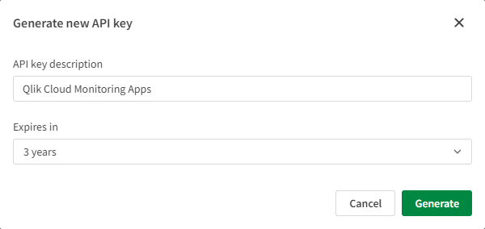

1. Copy the **API key** and store it in a secure location for safe keeping. This key is required to create the REST connection required to reload the app.

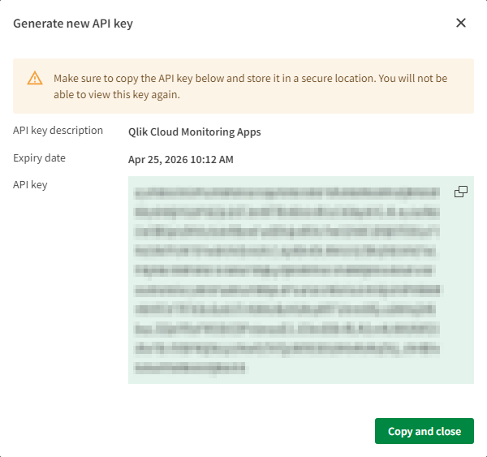

## Create Data Connection for the Monitoring Apps

1. Navigate to the space of your choice and select **Space details** and then **Data sources**.

1. Under **Data connections**, select **Add connection**.

1. Select the **REST** connector.

1. Set the **URL** to *https://<tenant>.<region>.qlikcloud.com/api/v1/items*, replacing the *<tenant>.<region>* to match the environment to be monitored.  
   **Example:** *https://company.us.qlikcloud.com/api/v1/items***Note:** The default hostname is recommended as the alias hostname may change over time.

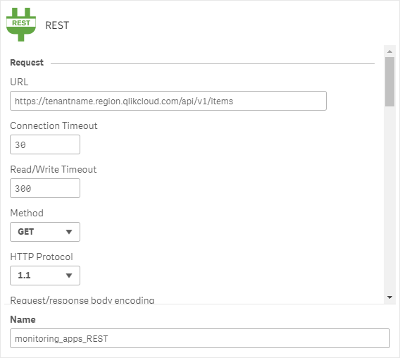

1. Use the default values for the settings and scroll down to the **Additional request parameters** section.
2. A black and white text

   Description automatically generatedUnder **Query Headers**, add the name **Authorization** and set the value to **Bearer <paste API key here>.** In addition, ensure that the **Allow “WITH CONNECTION”** option is enabled.
3. Rename the connection to **monitoring_apps_REST**. This is the default connection name that is set in the load script of the app. Click **Create**.

**Note:** The connection will not save if the API key is not valid.

# Import and Configure the Monitoring Application

## Import the Monitoring Application

1. Go to the **Hub > Add new > Upload app**.
2. 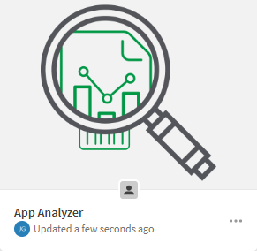**Drag and drop** or **browse to the location** to upload the application into the environment. Choose the **Space**, add **tags** if necessary, and click **Upload**.

## Configure the Monitoring Application

1. Open the application and go to the **Data load editor**.
2. Navigate to the **\*\* Configuration \*\*** tab and verify the vu_rest_connection variable value matches the name and space of the REST connection from Create the Data Connection for the Monitoring Apps. If it does not match, update the variable.

**Note:** ‘:monitoring_apps_REST’ uses the relative path which will check for a connection in the current space. The full path may also be used, as such: <Space Name>:<Connection Name>.

|  |
| --- |
| The following step does not apply for the **Access Evaluator** application, as that application does not leverage QVDs. |

1. Verify the vu_qvd_storage_connection variable value and adjust if necessary. This is the location where incremental QVDs will be stored.

**Note:** ‘Lib://:DataFiles’ uses the relative path which will check for a connection in the current space. The full path may also be used, as such: <Space Name>:<Connection Name>.

1. The application is now ready to reload. Click **Load data** in the top right-hand corner to reload the app.

# Troubleshooting

## Reload Analyzer

**Large Amount of Data**

If while reloading the application a 500 (Internal Server Error) is presented, this is likely due to the fact that the tenant has a large amount of reload data, and the 90 day range (default) is too large.

1. Navigate to the **\* Optional Configuration \*** tab.
2. Find the vu_initial_days_back variable and adjust it to a smaller range. The default is 90, so it must be an integer less than that number. Repeat this step until the reload no longer shows the 500 error.
   1. If set to 90 set to 60
   2. If set to 60 set to 30
   3. If set to 30 set to 7
   4. etc

**Note:** This variable is ignored in the load script following a successful reload. After a successful reload, the app will begin to build incrementally on whatever the foundation (vu_initial_days_back) was set to. Meaning, if vu_initial_days_back was set to 30, the app was reloaded successfully, and then vu_initial_days_back was set to 60, and the app was reloaded successfully again, the result will not hold 60 days of data, but rather it will hold 30 days of data with the incremental addition of the time since the last reload. If it is desired to increase this number, the reload_analyzer_* QVDs would need to first be deleted. Hence, step 2 above shows that it is best to decrement this variable rather than increment. If chosen to increment, QVDs will need to be deleted prior to the subsequent reload for the variable to function properly.

## App Analyzer

**Receiving 404 Errors**

If while reloading the application a (Connector error: The remote server returned an error: (404) Not Found.) error is presented. This is caused by an application being deleted while the application is being reloaded, hence its metadata can no longer be fetched.

1. Navigate to the **\*\* Configuration \*\*** tab.
2. Find the ErrorMode variable and set it to 0. This will prevent the script from halting on those errors. Only make this modification once you are confident that the application is properly reloading other than these occasional errors occurring.



**About Qlik**

Qlik’s vision is a data-literate world, where everyone can use data and analytics to improve decision-making and solve their most challenging problems. Qlik provides an end-to-end, real-time data integration and analytics platform to close the gaps between data, insights and action. By transforming data into active intelligence, businesses can drive better decisions, improve revenue and profitability, and optimize customer relationships. Qlik does business in more than 100 countries and serves over 50,000 customers around the world.

**qlik.com**

© 2020 QlikTech International AB. All rights reserved. All company and/or product names may be trade names, trademarks and/or registered trademarks of the respective owners with which they are associated.